| Name: | Akshaya K |
| --- | --- |
| Date: | 19 September 2022 |
| Team ID: | PNT2022TMID37456 |
| Project Name: | Personal Expense Tracker Application |
| Marks allotted: | 4 marks |

**Ideation phase:**

**Ideation**

The current scenario has changed the face and pace of the technological and computing industry and has redefined humans reliance on it. With this evolving time and technology, I am extremely delighted to put forward my meticulous outcomes to such a field of infinite potential and that I truly believe that this burgeoning industry holds tremendous futuristic developments.

In Today’s Digital World there are a very few applications that have the discipline and diligence to stick to the goals, as it takes a relentless dedication to achieve a competent personal budget in order to ease the Consumer’s day to day life.

This Project was developed including all the phases from mapping out the problem to delivering final designs with the responsibilities of Qualitative Research, UX Design, Visual Design, Prototyping, and Testing.

It was fancied to design an application to overcome this problem and help users through tracking and categorising the expenses by the means of visualisation. This prototype shows your monthly cash flow with an ability to break down expenses by category and dig in deeper where you see concerning spending habits.

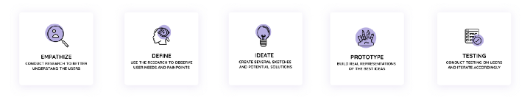**User Research:**

**This case study started with the systematic thought process by constructing the survey report of target users to understand their requirements and also identify their behavioural patterns with respect to adding the realistic contexts and insights to design processes- i.e pain points, their necessity, requisite and motivations.**

**Following is the drafted questionnaire,**

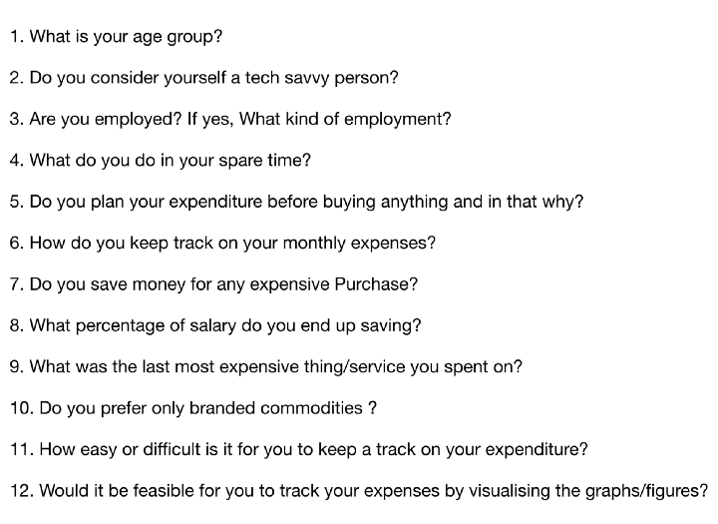

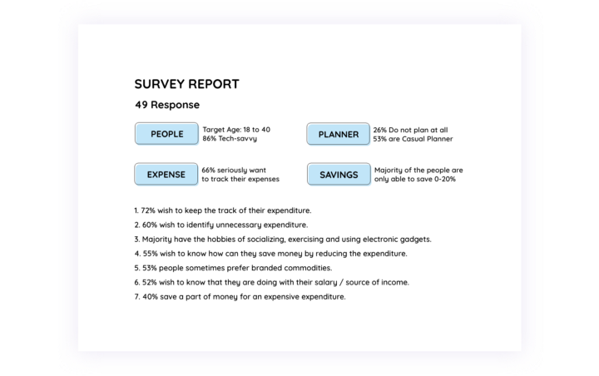

# **Competitive Analysis**

**Already there are many existing money manager applications.**

**According to users and developers perspective some observations were made.**

# **User Personas**

**Based on the interviews and Competitive analysis it turned up with three distinct people with their respective pain point, motivations and goals. People with such traits can be represented through a fictitious character called as Persona.**

# **Bridging the gap between pain points to ideas**

**Based on the analysis , all the major insights, needs were listed down and then ‘how might we’ (HMW) questions were created which was helpful to kickstart the ideation phase.**

